Library Management System - User Manual
Table of Contents
- Introduction
- System Requirements
- Installation Instructions
- Launching the Application
- User Roles and Functionalities
- Administrator
- Librarian
- Student/User
- Common Operations
- Logging In
- Searching Books
- Borrowing Books
- Returning Books
- Viewing Transaction History
- Managing Books (Admin/Librarian)
- User Registration (Student)
- Error Messages and Troubleshooting
- FAQs
- Support

Introduction
This user manual guides you through using the Library Management System, a Java-based desktop application for managing library operations including book cataloguing, user management, borrowing, and fine tracking.

System Requirements
- Java Runtime Environment (JRE) 8 or higher
- MySQL Server
- 512 MB RAM minimum
- Windows/Linux/MacOS

Installation Instructions
- Ensure JRE is installed on your system.
- Set up the MySQL database as described in the setup guide.
- Run the application via your Java IDE or by executing the .jar file if exported.

Launching the Application
- Open your IDE or double-click the compiled JAR file.
- The login screen will appear.
- Enter your credentials and click Login.
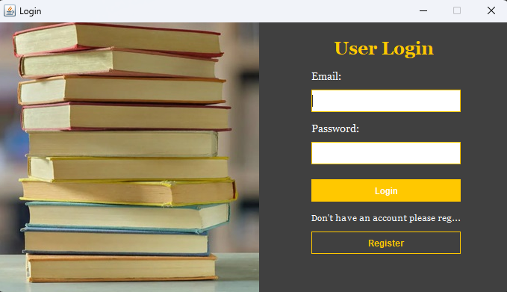

User Roles and Functionalities
Administrator
- Full access to all features
- Add/Edit/Delete users
- Manage book inventory
- Generates reports
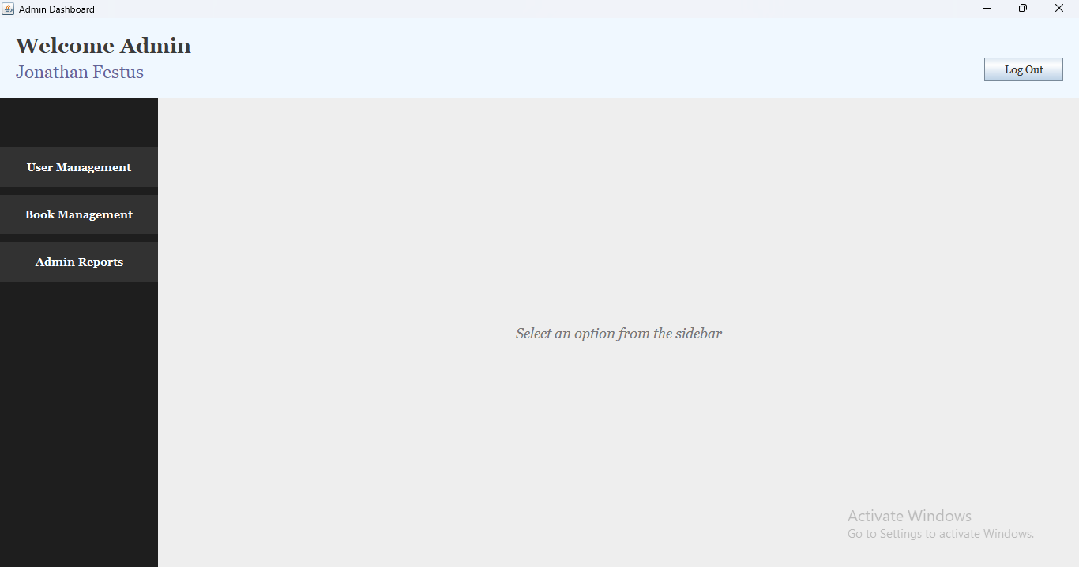

Librarian
- Add/Edit/Delete books
- View and process borrow/return transactions
- View reports
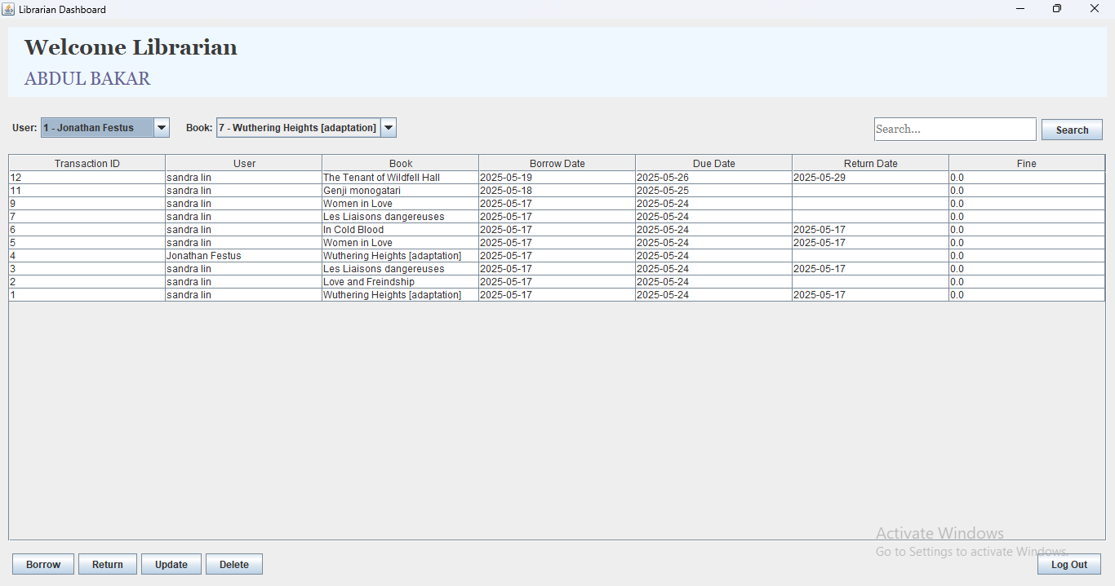
Student/User
- Register account (one-time)
- Login to search and request books
- View their own transaction history
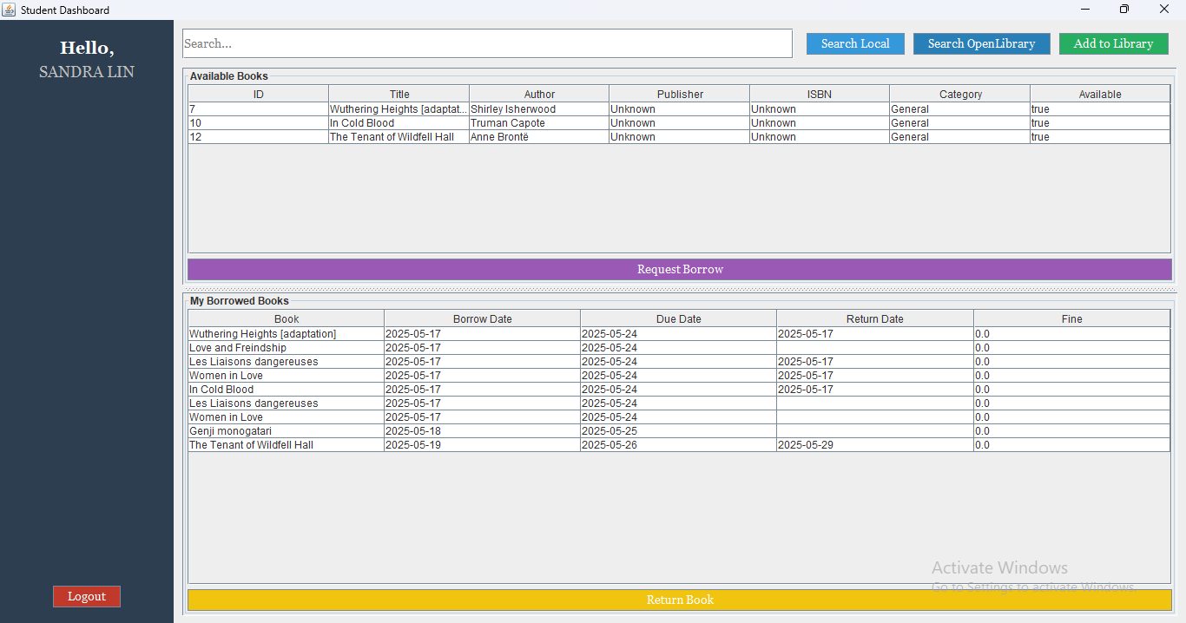

Common Operations
Logging In
- Open the application
- Enter your email and password
- Click Login
Searching Books
- Navigate to View Books section
- Use the search bar to filter by title, author, ISBN, or category
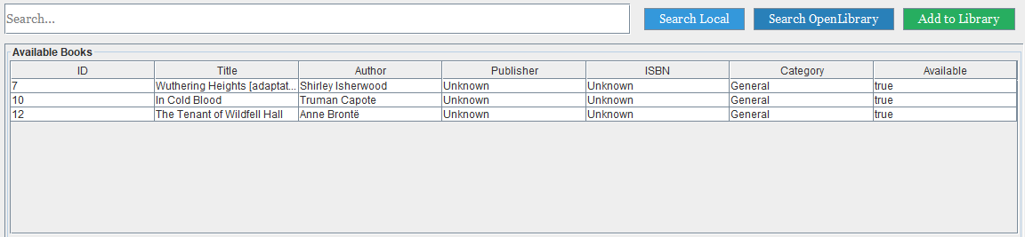
Borrowing Books
- Select a book from the list
- Click Borrow if available
- View borrow status in your dashboard
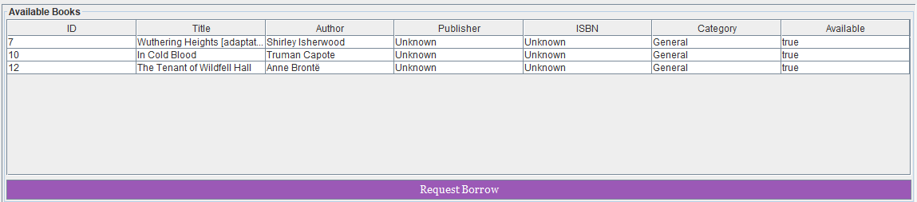
Returning Books
- Go to My Borrowed Books
- Select the book and click Return
- Fine will be displayed if overdue
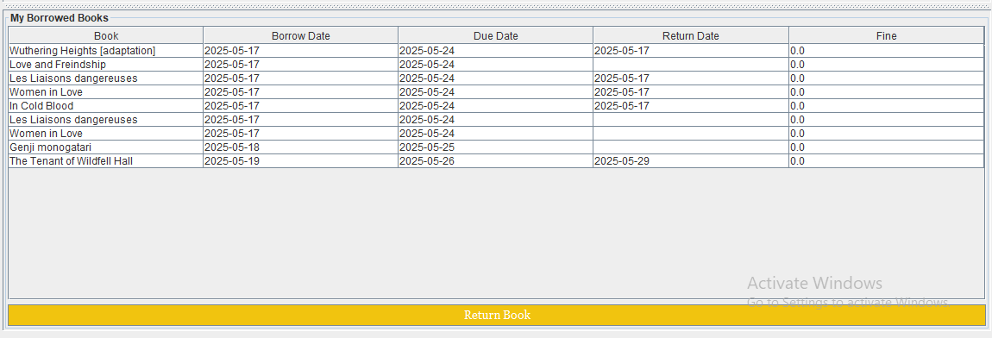
Viewing Transaction History
- Navigate to My Transactions (librarian)
- Admins/Librarians can see all transactions
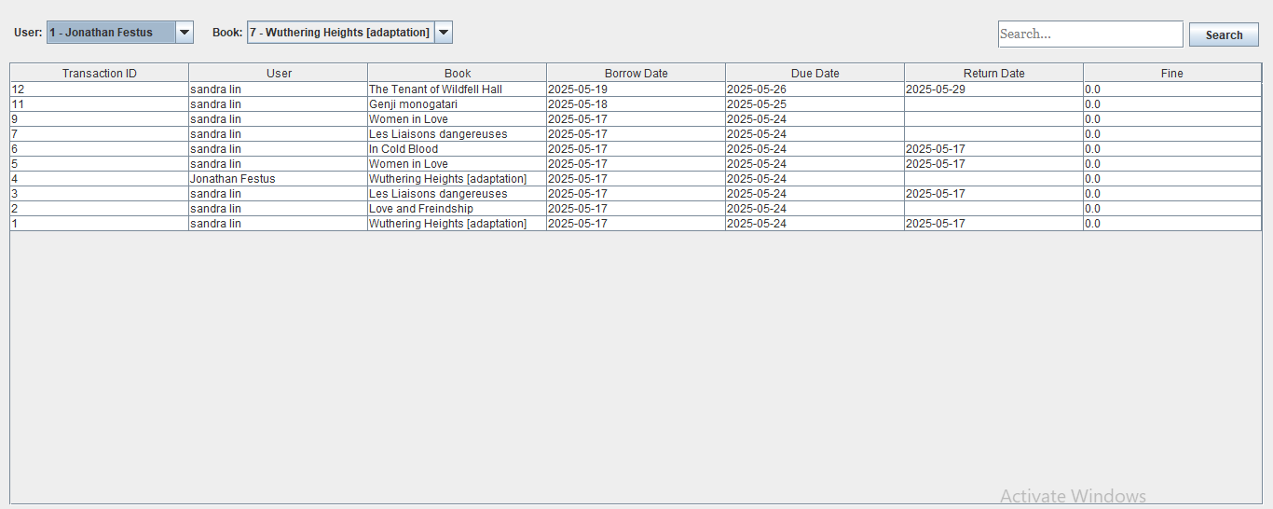
Managing Books
(For Librarians and Admins)
- Go to Manage Books
- Use Add, Edit, or Delete buttons to perform operations
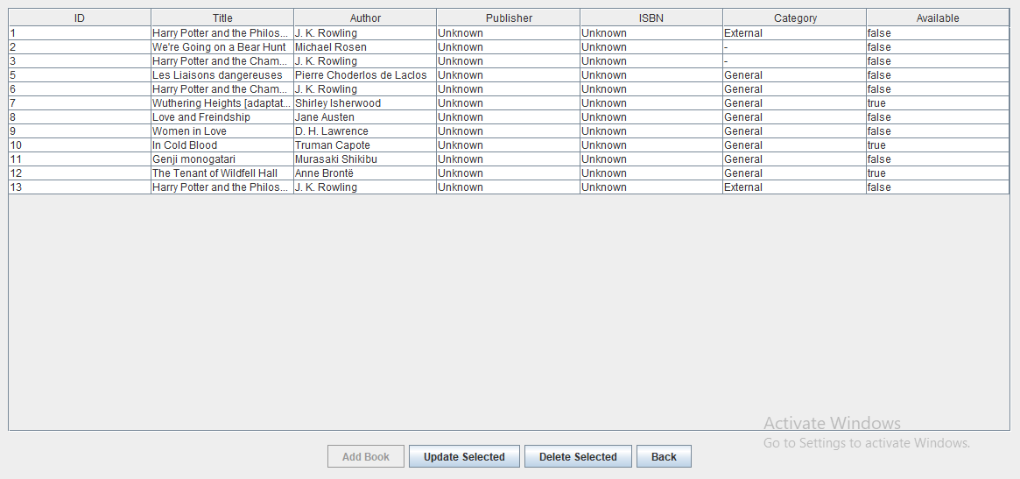
User Registration
(For Students)
- Click Register on the login screen
- Fill out the registration form
- Submit to create an account
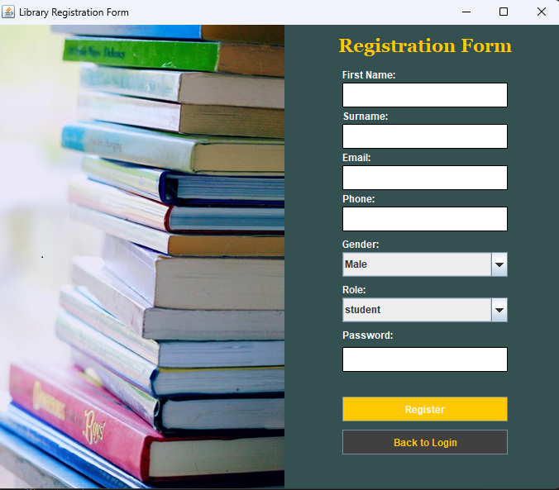

Error Messages and Troubleshooting
Error Message | Meaning | Suggested Fix
Invalid Credentials | Email/password mismatch | Check and re-enter your credentials
Fields should not be empty | Required fields left blank | Fill in all required fields
Book not available | Book is already borrowed | Wait for it to be returned

FAQs
Q: Can I reset my password?
A: Not yet; this feature is planned for future versions. Contact the admin.
Q: Can I borrow multiple books?
A: Yes, depending on the rules defined by the admin.
Q: What happens if I return a book late?
A: A fine is calculated based on the number of days overdue.

Support
For further assistance, contact your system administrator or email jfnde710@gmail.com.

